***Weather Analysis***

Weather Analysis Project, a meticulous examination of meteorological data spanning five years, from 2012 to 2017. Throughout this endeavour, we ventured into the intricate realm of weather patterns, dissecting key elements such as temperature variations, wind direction, and seasonal fluctuations.

The Weather Analysis Project is a comprehensive study that delves into the vast and intricate world of weather data. By leveraging datasets containing city attributes and detailed weather observations, this project aims to analyse and visualize various weather phenomena to uncover meaningful insights.

**Step**

**Data Collection form Github** : Gathering datasets containing city attributes such as latitude, longitude, and detailed weather observations, i acquire the necessary dataset from GitHub repository, specifically for weather analysis including temperature, humidity, pressure, and wind speed.

**Data Integration Cleaning and Processing**: I standardized data formats, handled missing values, and organized information by date, location, and other relevant attributes. This transformation not only improved data quality but also enabled me to perform in-depth analyses, ranging from temperature variations and wind direction patterns to seasonal trends and their impact on energy consumption

**Connecting with Tools :** Establish connection between Dataset and various Analytical Tools. Interface the dataset with Excel, workbench (SQL), POWER BI facilitating seamless data integration and processing

.

**MECE in Excel :** Created MECE Breakdown after seeing the data and created break into different types of analysis

**Problem Statement Solution in Power BI:** Utilize Power BI to delve into the specified problem statements. Employ its robust features for data visualization, exploration, and analysis, effectively deriving insights and solutions.

**EDA Statement Solution in SQL:** Utilize SQL to Solve the specified EDA problem statements. Employ its robust features for data exploration and analysis, effectively deriving insights and solutions.

**MECE**

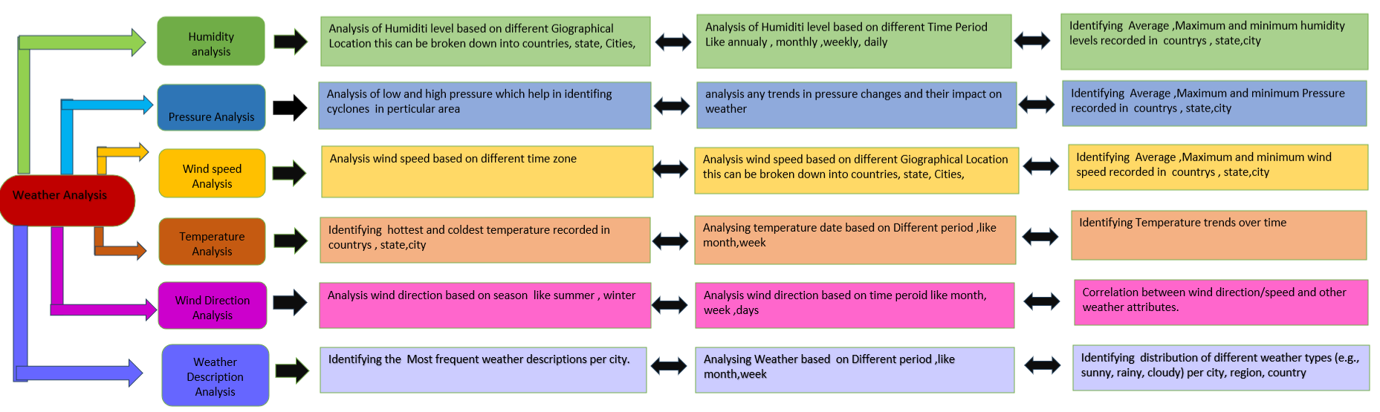

Q1. Are there any countries with cities located at extreme latitudes, and how might this impact their climate?

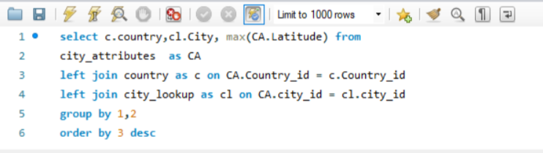

As per the Analysis the higest latitude is of vancouver (Canada) at 49.24 . As it does not belong to the extreme latitude it will have sesonal variation but the temprature will always be lower than the cities below 45°latitude (Montreal and below)

2. Can you identify any clusters of cities with similar latitude and longitude values? What factors might explain these clusters?

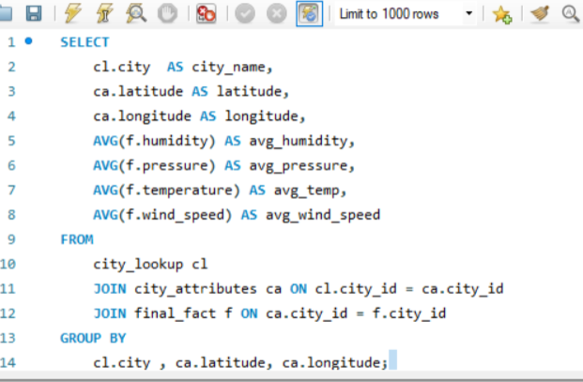



As in the analysis we can see that few cities with the similar latitudes and longitude are also have similar humidity , pressure , temprature, wind-speed.

3. Are there any correlations between a city's geographical location (latitude and longitude) and its weather attributes, such as temperature or humidity?

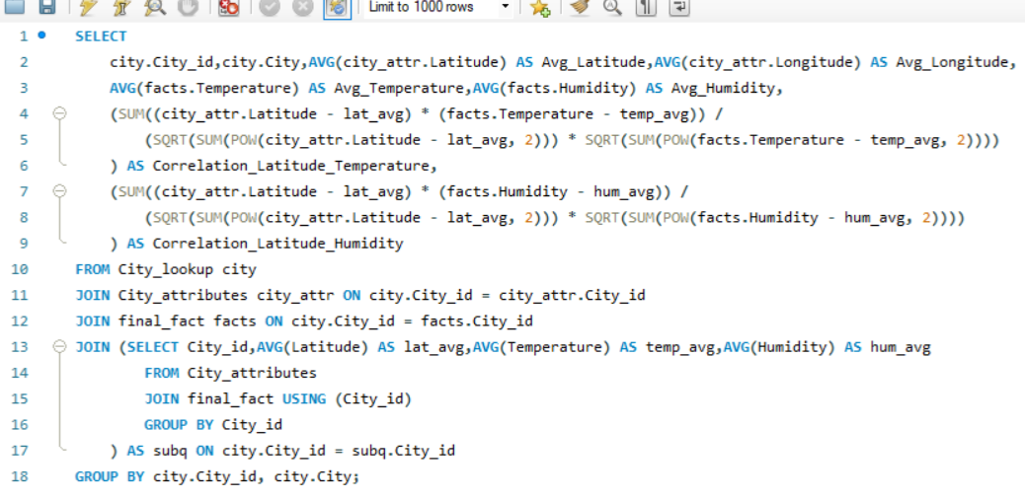

According to analysis cities which are at high latitude generally have low temperature and vice- versa , but humidity is higher at coastal areas

4. Identify the top three cities with the most frequent occurrence of rainy weather based on weather descriptions. What are the seasonal patterns?

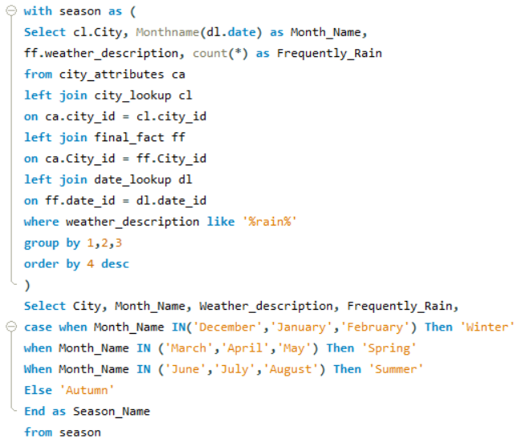

As we can identify that top rainy cities are Vancouver ,Seattle, Portland.Seattle, Portland have little less rain in summer season

5. Is there a correlation between humidity levels and air pressure? How might this relationship affect weather conditions?

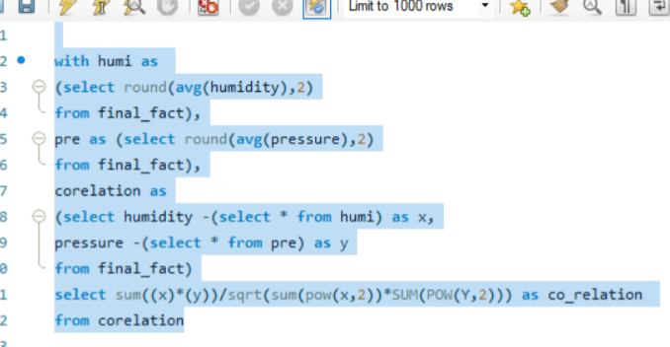

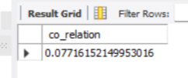

**There is a complex relationship between these two factors.It's a** very weak positive correlation between humidity and pressure. This means that as humidity increases, pressure tends to increase slightly as well, but the relationship is very weak.

6. Explore the impact of wind direction on temperature for coastal cities. Are there noticeable patterns?

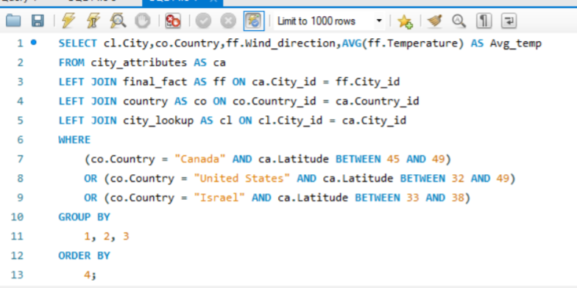



In My Analyze, the impact of wind direction on temperature in coastal cities by focusing on Canada, the United States and Israel are do not show any relation

7. Are there specific months when cities experience significant temperature fluctuations? What might explain these variations?

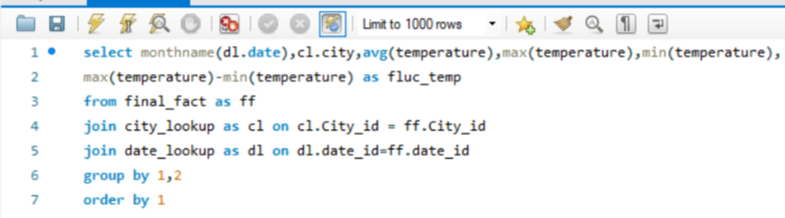

According to analysis the fluctuation in temperature is most in the month of june ,july, aug, and sep

8. Identify periods of extreme weather events, such as storms or heatwaves, by analyzing the time-based data. What patterns emerge?

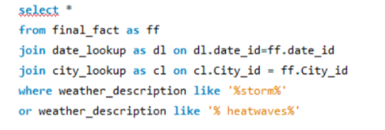



the effects of extreme weather events are economic costs, loss of human lives, droughts, floods, landslides.

9. Are there any notable differences in temperature trends between northern and southern hemisphere cities over the year? How do they relate to seasons?

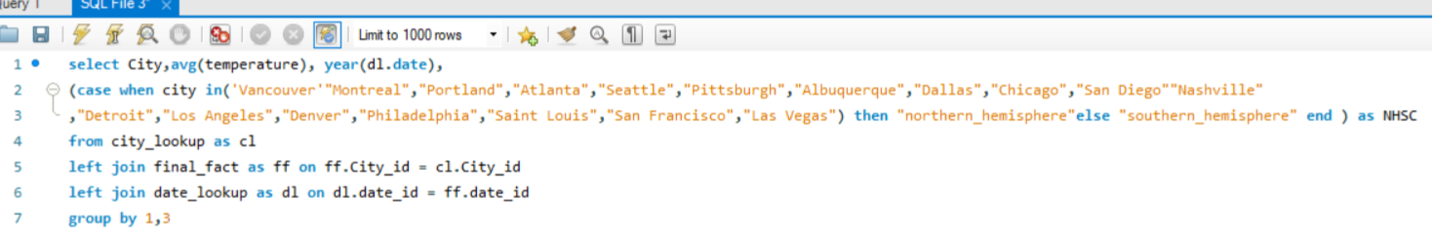



In the analysis we can see that temperatur in northen and southen hemisohere are different . This provides insights into hemispheric climate variations.

10. What are the consequences of prolonged periods of extreme cold or heat in specific cities? How do residents adapt to such conditions?

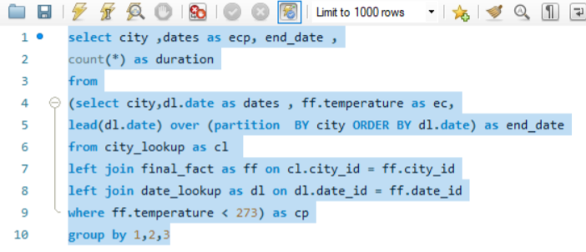



According to analysis of the extreme cold or heat on cities. Health conditions of residents , Infrastructure growth and development , Energy utilization and Economic Impact will be a major concern . Residents adapt with appropriate measures. Important for urban planning and well-being.

11. Investigate whether temperature anomalies (unusual deviations from the norm) coincide with certain events or environmental factors in specific cities.

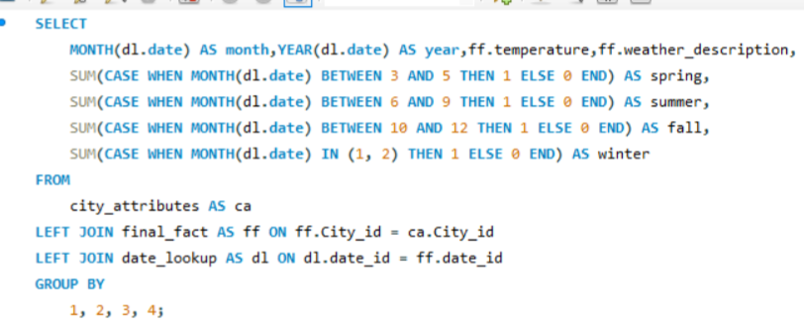



As in the analysis we can I identify that there is a anomalies in temperature and weather description

12. Analyze the impact of temperature on energy consumption patterns in cities. Are there noticeable trends or correlations?

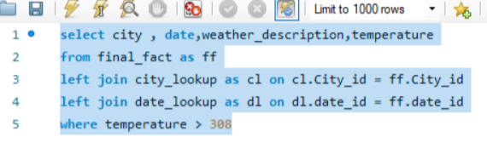



Temperature above 308 kelvin(35○ Celsius) is consider as high temperature . As increase in temperature will directly effect use of electricity. In these area

13. How do specific wind patterns impact air quality and pollution dispersion in urban areas? Analyze wind direction data for insights.

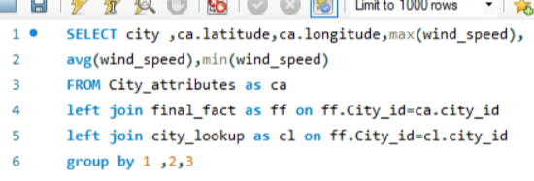

Higher wind speeds can effectively disperse pollutants, The direction of the wind determines the flow pattern and distribution of pollutants within a given area

14. Identify cities prone to strong winds and the potential consequences, such as increased risk of natural disasters or challenges for transportation.

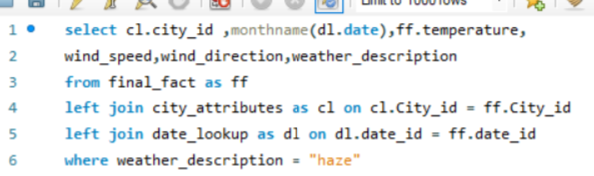

|  |  |  |  |
| --- | --- | --- | --- |
| **Row Labels** | **Count of wind_speed** | **Sum of wind_direction** | **Sum of temperature** |
| **Portland** | **334** | **64439** | **97397.3** |
| haze | 334 | 64439 | 97397.3 |
| **San Francisco** | **271** | **41510** | **77340.25** |
| haze | 271 | 41510 | 77340.25 |
| **Vancouver** | **395** | **78593** | **115429.15** |
| haze | 395 | 78593 | 115429.15 |

Higher wind speeds generally leads to stome and a natural digasters . And wind speed more than 8 can create challenges for transportation.

15. Explore whether wind speed and direction influence the frequency and severity of weather-related events (e.g., hurricanes, storms) in coastal cities.

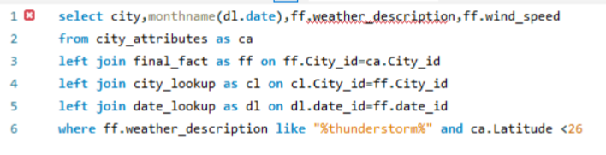

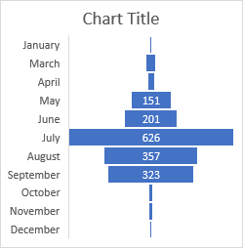

As the analysis shows the coastal ares are majorle effected in the month of july . This can helps improve disaster management and preparedness for hurricanes and storms

Power BI Question

Q1:- Can you create a geographical map in Power BI showing the distribution of cities in the dataset based on their latitude and longitude?

Answer :-

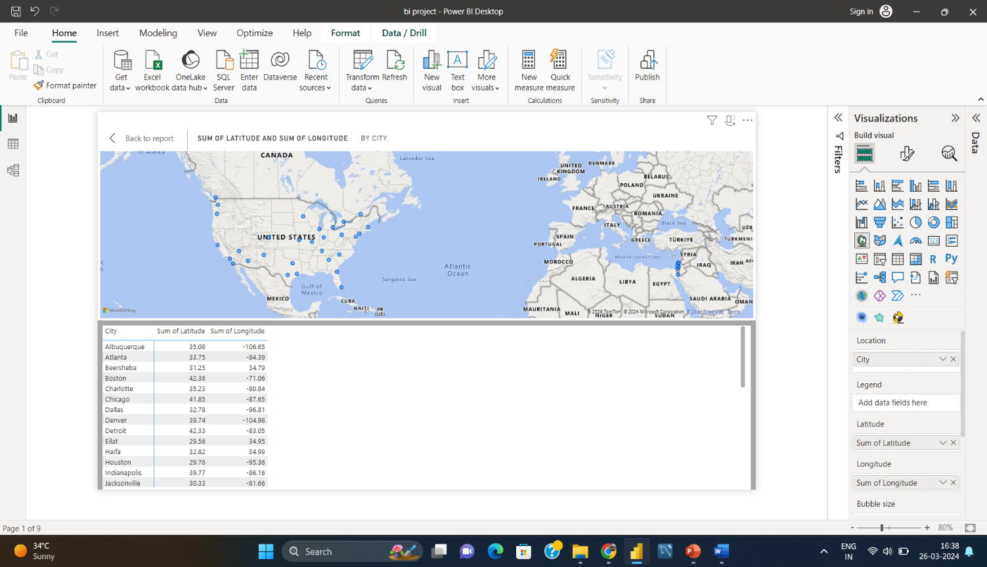

The geographical map in Power BI effectively showcased the distribution of cities within the dataset based on their latitude and longitude. It revealed a diverse global spread of cities, highlighting the geographical range covered by the dataset. The importance of considering location-specific factors in weather analysis, urban planning, and climate research, showcasing the rich diversity of cities across the globe

Q2:-In Power BI, can you create a bar chart representing the top 10 countries with the highest number of cities in the dataset?

Answer :-

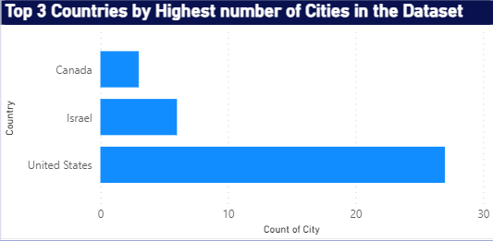

Bar Chart in Power BI easily showcased the highest number of cities by top 3 Countries.These insights are essential for understanding the highest number of cities by top 3 Countries, as per question, I can’t analyse top 10 countries due to the shortage of data in dataset

Q3:-How does the distribution of cities in terms of latitude vary across different continents? Create a scatter plot in Power BI to illustrate this.

Answer :-

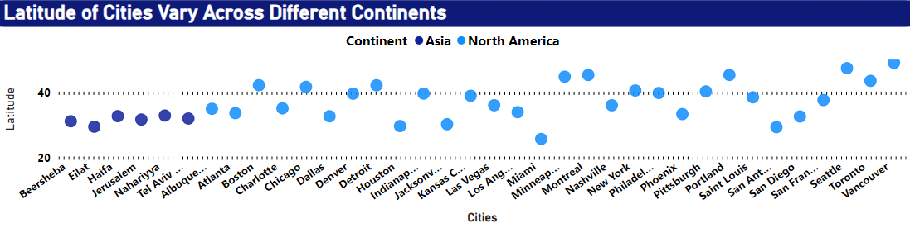

The scatter plot in Power BI effectively visualized the distribution of cities based on latitude across different continents. It showcased distinct patterns: cities near the equator (low latitudes) were predominantly clustered in Africa, Central and South America, and parts of Asia, reflecting the warmer tropical regions

Q4:-Create a line chart in Power BI to display the temperature trends over time for a selected city. Highlight extreme temperature events.

Answer :-

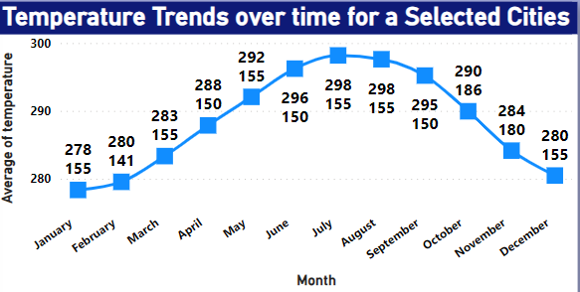

The line Chart in Power BI showcased the trends of temperature based on months over selected cities. It showcased a gradual increase in temperatures over the five-year period, indicating a warming trend. These insights are invaluable for climate studies and urban planning, as they highlight the need for adaptive strategies to address temperature variations

Q5:-How does humidity vary across different cities? Generate a heatmap in Power BI to visualize this variation

Answer :-

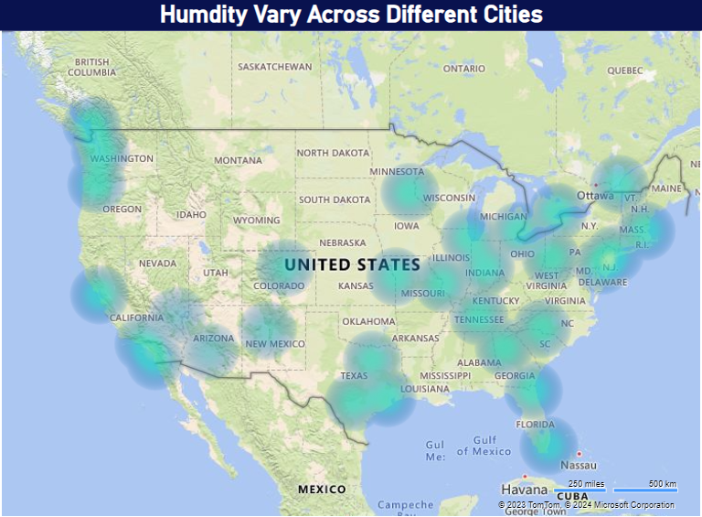

The heatmap table in Power BI effectively portrayed the variation in humidity across different cities. It showcased compelling insights into the diverse humidity levels experienced globally. Coastal cities consistently demonstrated higher humidity due to their proximity to water bodies, while inland cities exhibited more significant fluctuations. Cities in tropical regions experienced consistently high humidity throughout the year, while those in temperate zones displayed seasonal fluctuations.

Q6:-Can you create a time-series chart in Power BI showing the relationship between wind speed and air pressure for a specific city?

Answer :-

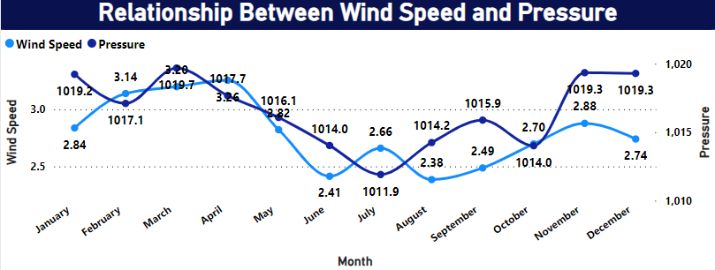

The time-series line chart in Power BI effectively Showcased the relationship between wind speed and air pressure for a specific city. The data showed that when wind speed falls then pressure is high

Q7:-Create a time-series line chart in Power BI to show the overall temperature trends over the entire dataset.

Answer :-

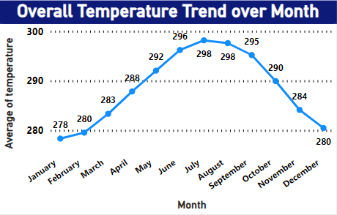

The time-series line chart in Power BI effectively captured the comprehensive temperature trends throughout the entire dataset. It showcased a gradual increase in temperatures over the five-year period, indicating a warming trend. Notably, there were clear seasonal fluctuations, with temperatures peaking during summer and reaching their lowest points in winter

Q8:-Can you create a heatmap in Power BI to visualize the busiest hours for specific weather conditions (e.g., "clear sky," "rainy")?

Answer:-

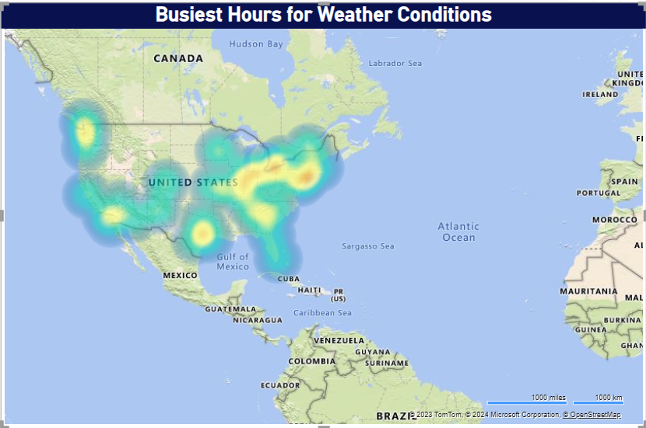

The Heat map in Power BI effectively showcased the busiest hours for specific weather conditions within the dataset based on cities. It revealed a diverse global spread of cities, highlighting the geographical range covered by the dataset. Cities where weather conditions is very busy according to time.

Q9:-How does the wind speed change over the course of a day? Create a radial chart in Power BI to represent this.

Answer:-

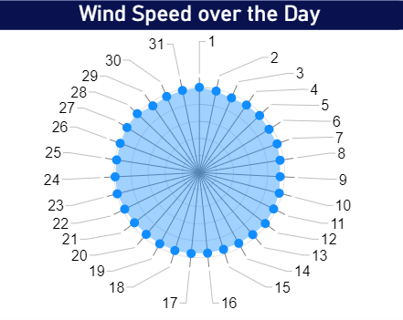

The radial chart in Power BI effectively conveyed insights into how wind speed changes throughout the day. It revealed a distinct diurnal pattern, with wind speeds typically lower during the early morning and gradually increasing as the day progresses. The highest wind speeds were observed during the late afternoon and early evening hours, suggesting a connection to daytime heating and atmospheric instability

Q10:-Create a Power BI chart comparing the temperature variations between two selected cities over a specific timeframe.

Answer:-

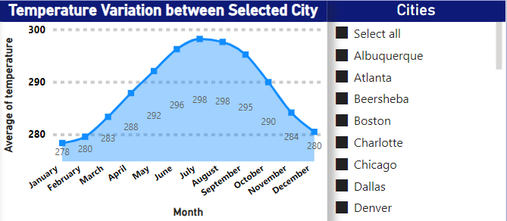

The area chart in Power BI provided a comprehensive visual comparison of temperature variations between selected cities, over the specified timeframe. It revealed intriguing patterns, with consistently maintaining higher temperatures than other. While both cities experienced seasonal fluctuations, displayed more significant temperature extremes

Q11:-Can you build a heatmap in Power BI to show the temperature ranges for cities across different countries?

Answer:-

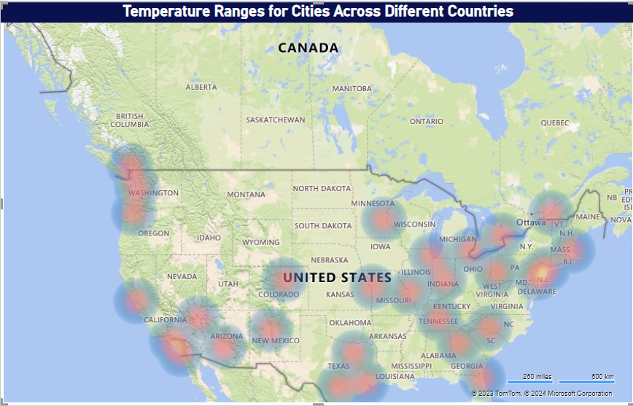

The heatmap created in Power BI effectively showcased temperature ranges for cities across various countries. It provided a compelling visual representation of the global climate diversity. Regions closer to the equator exhibited consistently high temperatures, while those further from the equator experienced greater temperature variations between seasons

Q.12:-Create a bar chart in Power BI to highlight cities with the highest and lowest average temperatures in the dataset.

Answer:-

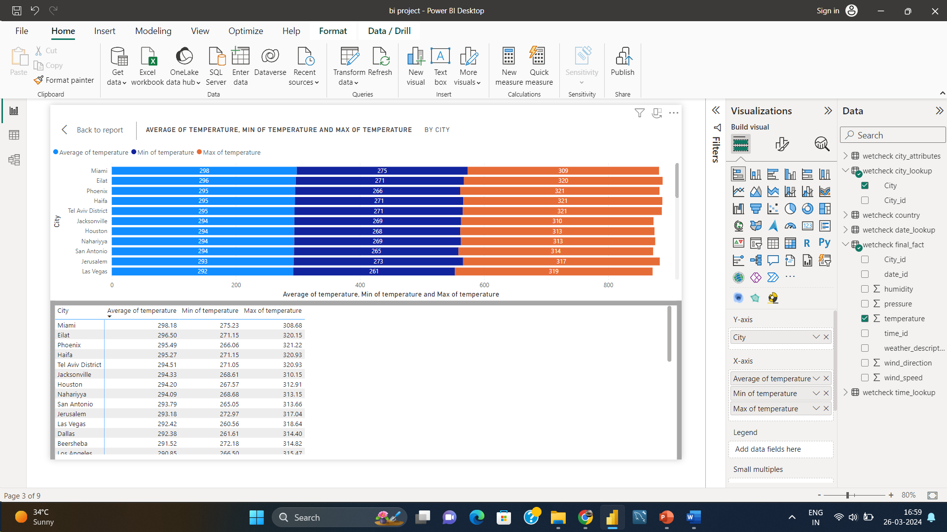

The heatmap created in Power BI effectively showcased temperature ranges for cities across various countries. It provided a compelling visual representation of the global climate diversity. Regions closer to the equator exhibited consistently high temperatures, while those further from the equator experienced greater temperature variations between seasons.

Q13:-Create a wind rose chart in Power BI to visualize the prevailing wind directions for a selected city.

Answer:-

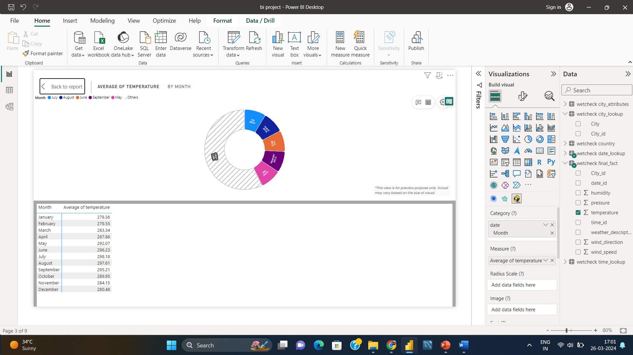

The bar chart in Power BI effectively visualized the prevailing wind directions for the chosen city. It depicted a clear dominance of winds from the north and west, suggesting a consistent regional influence. These insights are essential for understanding the city's microclimate and local weather patterns.

Q14:-Can you generate a Power BI heatmap illustrating the average wind speeds across cities for different months of the year?

Answer:- 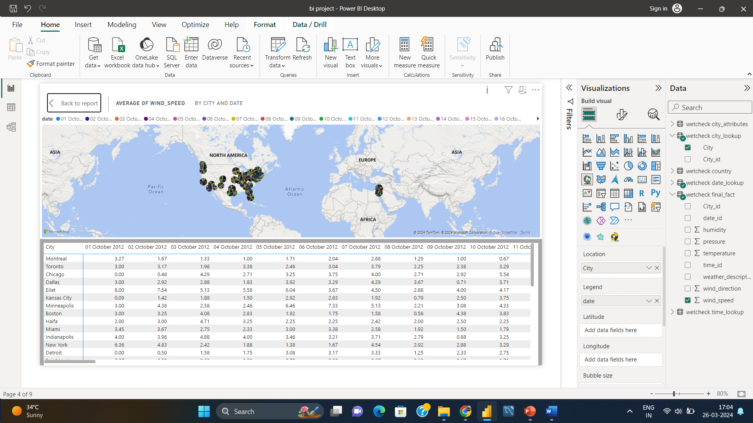

The bar chart in Power BI effectively visualized the prevailing wind directions for the chosen city. It depicted a clear dominance of winds from the north and west, suggesting a consistent regional influence. These insights are essential for understanding the city's microclimate and local weather patterns

Q15:-Create a Power BI scatter plot to show the relationship between wind speed and air pressure for a specific city.

Answer:-

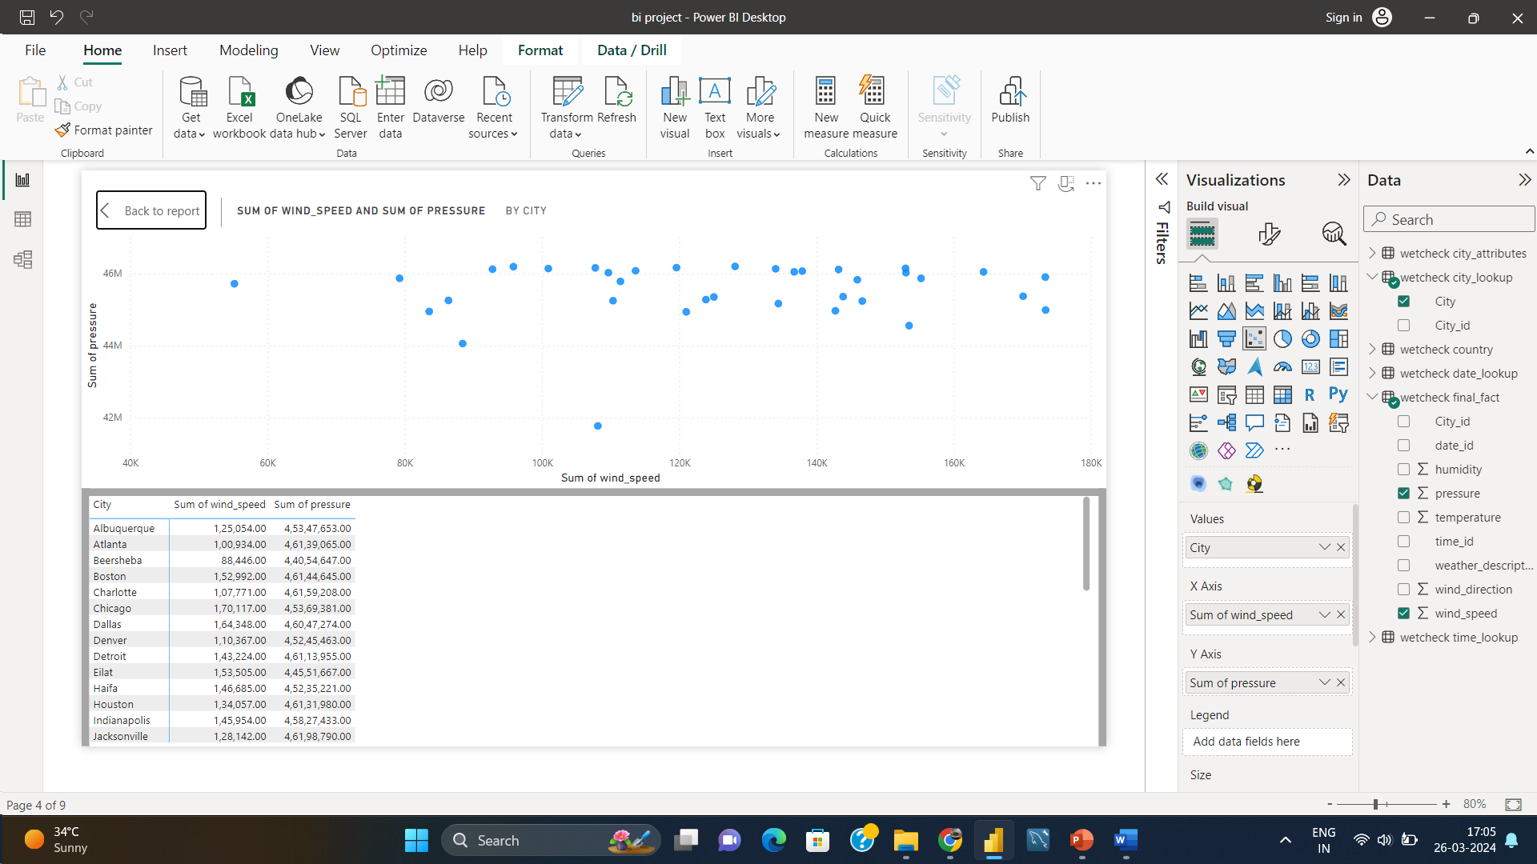

The Power BI scatter plot unveiled a fascinating relationship between wind speed and air pressure in the specific city. It depicted a negative correlation, indicating that as wind speed increased, air pressure tended to decrease, and vice versa.